Design Documentation

Contents

Assumptions 2

User stories 2

UML 3

Data model 3

Data Model 4

User Interface(UI) – Wireframes 5

Login 5

Quiz list 5

View/edit Admin Permission 5

View Permission 6

Limited User Permission 6

Quiz 7

Create new 7

View 7

Edit 8

Delete 8

Question & Answer 9

Create new 9

Edit 10

View 10

Delete 11

# Assumptions

The following have been assumed:

* Viewing and editing section: “A user with Restricted permission can select a quiz from available quizzes. All questions from the selected quiz can be viewed on the screen. The user can click on a question to reveal the answer.
* Not required to look at or incorporate offline capability.
* Not required to be mobile compatibility, the initial prototype will only be tested to be desktop compatible.
* Not required to be accessible or adhere to accessibility W3 guidelines.
* This is a minimum viable product (MVP) and will not be deployed and live yet.
* It has been assumed that one user will log in at a time therefore multiple user load testing will not be looked at.
* By looking at the provided business requirements it has been specified that “Each question is associated with a set of between 3 and 5 answers.” It has been assumed that there will be a minimum of 3 required answers and the last two answers (4&5) are optional.
* It has not been specified whether there will be multiple answers to a question or just one answer per question. Therefore, the number of answers will be left open to add multiple answers if required.

# User stories

|  |  |  |
| --- | --- | --- |
| **As a …** | **I can…** | **So that…** |
| All users | Login | I can access the quiz manager application. |
| All users | View a list of quizzes | I can choose a quiz |
| All users | Select a quiz | I can see questions and the associated answer choices to take a quiz. |
| Edit/view Admin and Viewing User | View answers to questions | I can check if my chosen answer is correct. |
| Edit/view Admin User | create new quiz categories | Expand the list and allow users to use more quizzes. |
| Edit/view Admin User | Create new Questions with answer choices and answers | Expand the list and allow user to use more quizzes. |
| Edit/view Admin User | Edit quiz titles | I can correct the information |
| Edit/view Admin User | Edit questions | I can correct the information |
| Edit/view Admin User | Edit answers choices | I can correct the information |
| Edit/view Admin User | Edit answers | I can correct the information |
| Edit/view Admin User | delete quiz titles | I can remove the information that is no longer needed |
| Edit/view Admin User | delete questions | I can remove the information that is no longer needed |
| Edit/view Admin User | delete answers choices | I can remove the information that is no longer needed |
| Edit/view Admin User | delete answers | I can remove the information that is no longer needed |
| All users | Logout | others cannot access the application as that user. |

## UML

The Use case Diagram shows the different permission roles and their available actions:

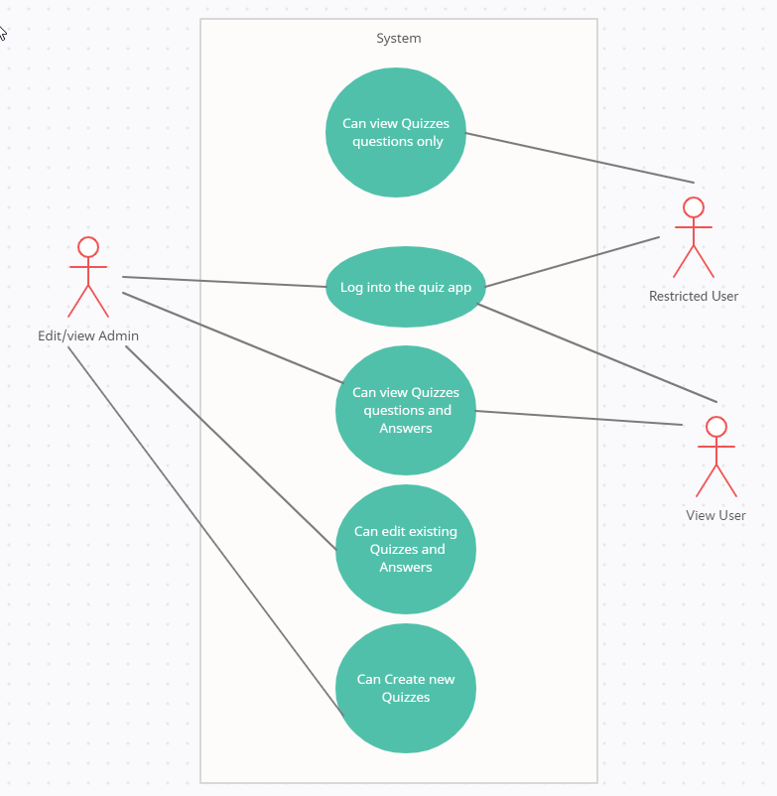

Figure - Use case diagram showing permissions role interacting with the system.

# Data model

The data model has been designed in an online software called Creately.

There are 4 tables; Users, User roles, Quiz, Questions & answers.

Users to User roles tables have a 1 to 1 relationship and is mapped together by the primary key from the ‘ Users’ table acting as a foreign key in the ‘User roles’ table.

The Quizzes to Question & answer tables have a 1 to many relationship, where one quiz can have many questions. The tables are mapped together by the primary key from the ‘Quiz’ table (QuizId) acting as the foreign key in the ‘Questions & answers’ table.

## Data Model

# User Interface(UI) – Wireframes

Here are a series of designs via wireframes to show the general planned UI of the Quiz manager.

There will be a home page where will be a login button for the user to login at the top. This and the login page can be accessed without logging in.

Figure 2 – Homepage.

## Login

The login page will have an email address input and password input to login.

If the incorrect credentials are input a message will appear stating the information is incorrect.

Figure 3 – Login page.

## Quiz list

### View/edit Admin Permission

When the admin logs in they can view a list of all quizzes with the associated questions and answers. They can create new, edit existing and delete quizzes, questions, and answers.

This will be seen via a link text button seen in the wireframe on the right of the table and at the top left.

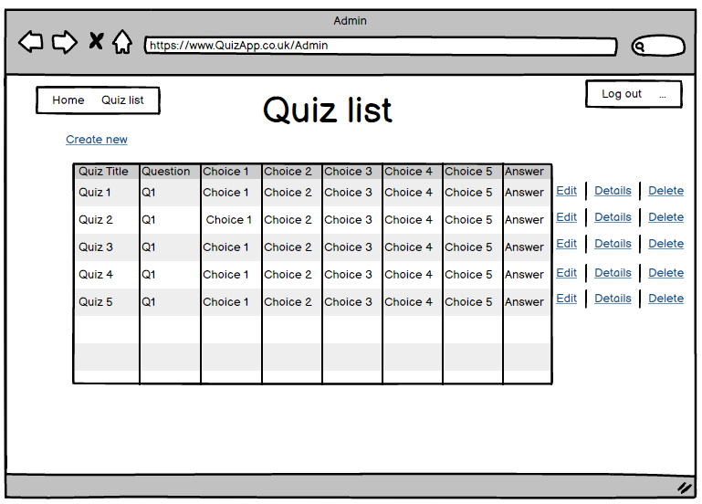

Figure 4 - View/edit admin quiz list view.

### View Permission

The difference in permission means the ‘View user’ can only see quizzes and answers. When the user clicks on the ‘reveal answer’ text link button they are directed to a view with the answer. There will be no ability to edit, delete or create new.

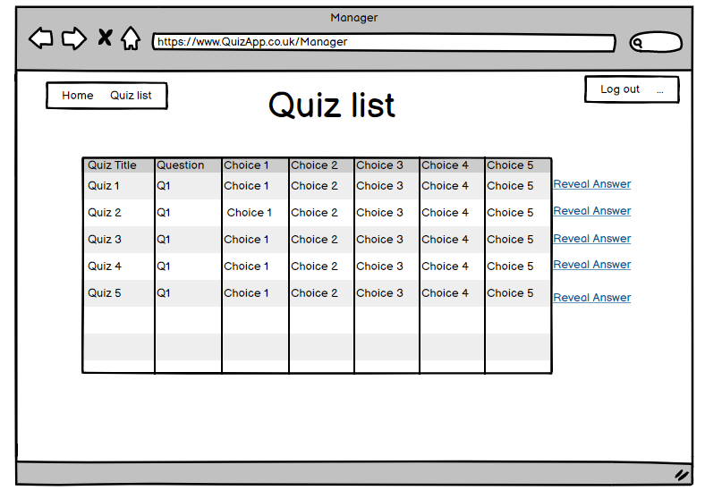

Figure 5 - View user quiz list view.

### Limited User Permission

The limited user can only see quizzes and their associated questions and answer choices with no answers. There will be no ability to edit, delete or create new.

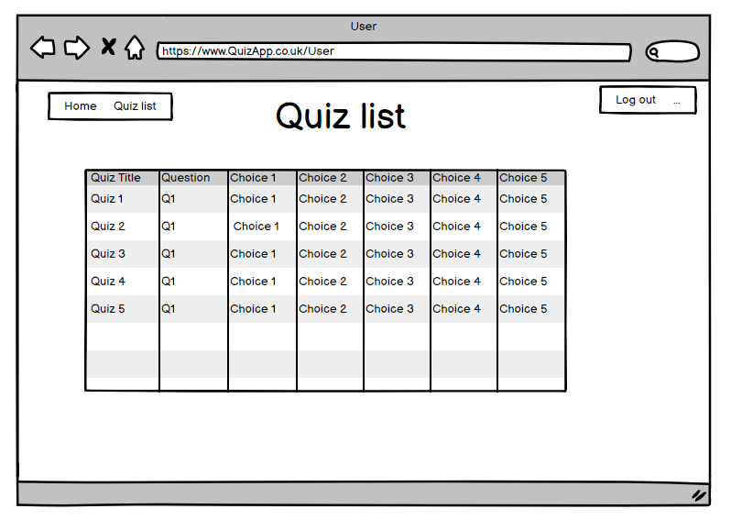

Figure 6 - Restricted user quiz list view

## Quiz

### Create new

This page will only be seen by the View/edit admin. There is string text input for the quiz name to create a new quiz. There is a back button to change your mind and not create a new quiz and a submit button to create a new quiz title. Quiz title is a required field, and a blank entry will not be allowed to be submitted. A message will pop up informing the user a blank entry is not allowed.

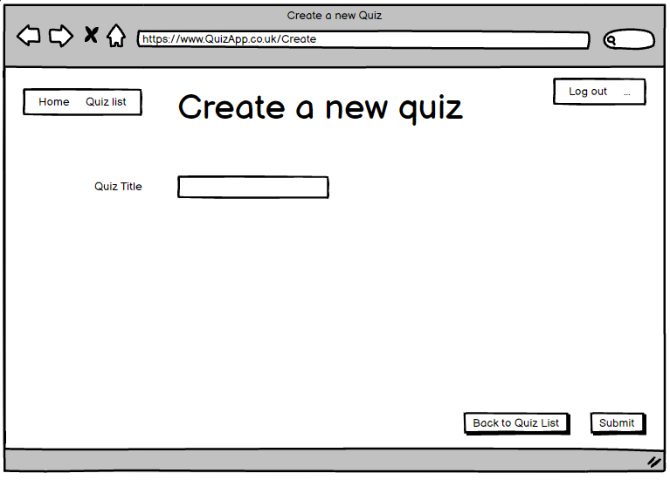

Figure 7 - create new quiz page.

### View

All users can see the quiz title page. There is a button to go back to quiz list.

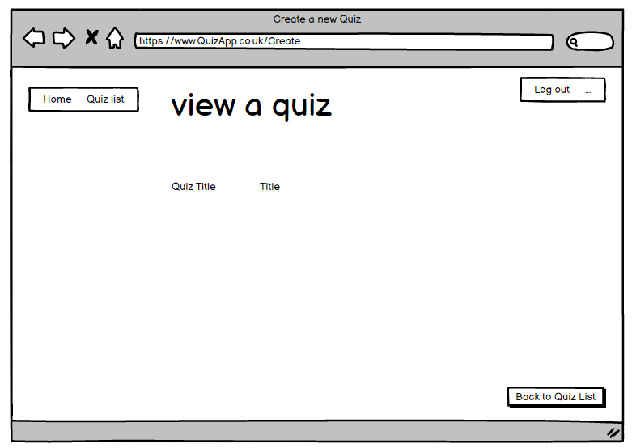

Figure 8 - View a quiz page.

### Edit

Only the edit/view admin can see this page. The string text input field can be edited to change the existing text present. The changes can be confirmed by clicking submit. Alternatively, the back to quiz list can be clicked to exit without saving any changes.

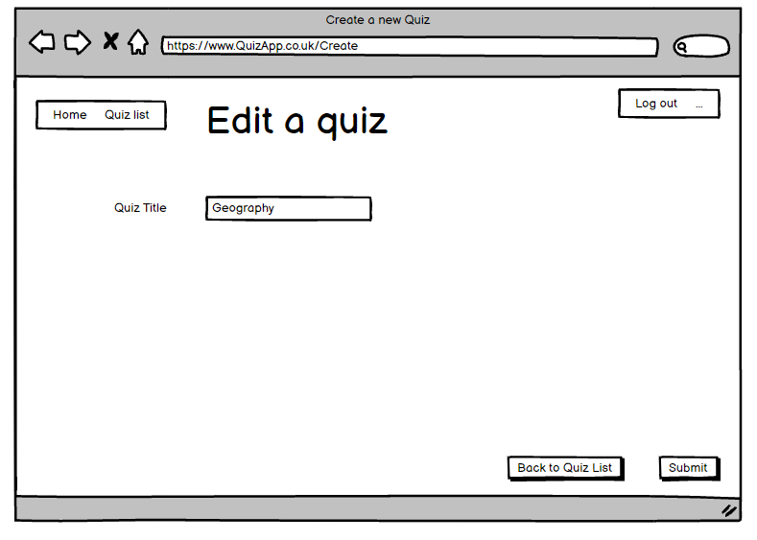

Figure 9 - Edit a quiz page.

### Delete

Only the edit/view admin can see this page. This item can be deleted by clicking submit. Alternatively, the back button can be clicked to exit without saving any changes.

Figure 10 - Delete a quiz page.

## Question & Answer

### Create new

Only the edit/view admin can see this page. The quiz title is a drop down from a list of existing quizzes to associate the question to the right quiz. The other fields are string text input. Question, answer, answer choices 1 to 3 are required but 4 and 5 are optional. A message will pop up if the required fields are not filled in.

Figure 11 - Create a new question page.

### Edit

Only the edit/view admin can see this page. The string text input fields can be edited to change the existing text present. The changes can be confirmed by clicking submit. Alternatively, the back to quiz list can be clicked to exit without saving any changes. The quiz title can be changed, it is a drop down from a list of existing quizzes to associate the question to the another quiz.

Figure 12 - Edit a question page.

### View

Only the edit/view admin and View User can see this page. There is a back button to exit the page.

Figure 13 - View a question page.

### Delete

Only the edit/view admin can see this page. This item can be deleted by clicking submit. Alternatively, the back button can be clicked to exit without saving any changes.

Figure 14 - Delete a question page.